PROGRAM 4 : Tuple-Based Course Registration Validation
1. Problem statement
Develop a Python program that represents course registrations as tuples containing a student ID and a course code. The program must identify duplicate registrations, invalid courses, and invalid course combinations according to the supplied rules. Finally, it should display the students whose registrations violate the rules and provide a summary of the errors.
2. Objectives
- Store course registrations using tuples.
- Identify duplicate student-course registrations.
- Check whether course codes are valid.
- Detect students who select incompatible courses.
- Display students who violate registration rules.
- Apply computational thinking and fundamental Python concepts.
3. Assumptions and rules
Item | Rule
Available courses | CS101, MA101, AI101, CS102
Registration format | (student_id, course_code)
Duplicate | Same student registers for the same course more than once
Invalid course | Course code is not in the available course list
Invalid combination | A student selects both CS101 and CS102
Student violation | A student has at least one registration error
The incompatible-course rule is an example rule for this assignment, not an official college policy.
4. Computational thinking
- Decomposition: Divide the problem into storing registrations, checking duplicates, validating courses, and checking incompatible combinations.
- Pattern recognition: Identify repeated tuples and repeated error patterns.
- Abstraction: Focus on student IDs, course codes, and registration rules.
- Algorithmic thinking: Follow a sequence of steps to validate each registration and generate a final report.
5. Algorithm
- Start the program.
- Store available courses in a tuple.
- Store student registrations in a list of tuples.
- Create empty lists to store duplicate registrations, invalid courses, incompatible combinations, and violating students.
- Check each registration for duplicates and invalid course codes.
- Check each student's courses for incompatible combinations.
- Display the errors and the final summary.
- Display the errors and the final summary.
- Stop the program.

6. Flowchart

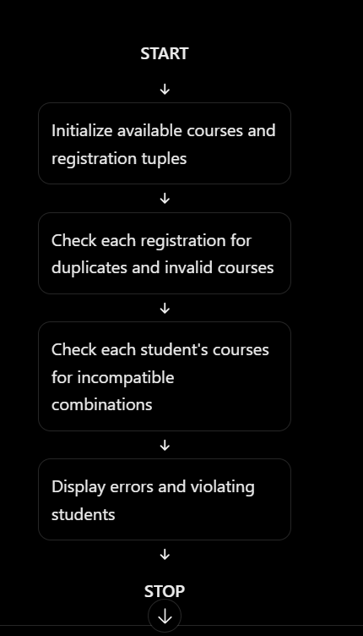
7.PESUDO CODE
START

Store available courses
Store registration tuples

Create empty lists for errors and violating students

FOR each registration
Unpack student ID and course code

IF registration already exists
Record duplicate registration
Mark student as violating
ELSE
Add registration to seen list
END IF

IF course code is not available
Record invalid course
Mark student as violating
END IF
END FOR

FOR each student
Collect the student's valid courses

IF student selected CS101 and CS102
Record invalid combination
Mark student as violating
END IF
END FOR

Display errors and final summary

STOP
8.PYTHON SOURCE CODE

# Tuple-Based Course Registration Validation

available_courses = ("CS101", "MA101", "AI101", "CS102")

registrations = [
("S101", "CS101"),
("S101", "MA101"),
("S101", "CS101"), # Duplicate
("S102", "AI101"),
("S102", "CS102"),
("S102", "CS101"), # Invalid combination
("S103", "XYZ999"), # Invalid course
("S103", "MA101"),
("S104", "AI101")
]

students = ["S101", "S102", "S103", "S104"]

seen_registrations = []
duplicate_registrations = []
invalid_courses = []
invalid_combinations = []
violating_students = []

print("===== COURSE REGISTRATION VALIDATION =====")

print("Available courses:", available_courses)

# Check duplicates and invalid course codes
for registration in registrations:
student_id, course_code = registration # Tuple unpacking

if registration in seen_registrations:
duplicate_registrations.append(registration)

if student_id not in violating_students:
violating_students.append(student_id)
else:
seen_registrations.append(registration)

if course_code not in available_courses:
invalid_courses.append(registration)

if student_id not in violating_students:
violating_students.append(student_id)

# Check incompatible course combinations
for student in students:
courses = []

for student_id, course_code in registrations:
if student_id == student and course_code in available_courses:
if course_code not in courses:
courses.append(course_code)

if "CS101" in courses and "CS102" in courses:
invalid_combinations.append(student)

if student not in violating_students:
violating_students.append(student)

# Display duplicate registrations
print("\nDuplicate registrations:")
if duplicate_registrations:
for registration in duplicate_registrations:
print(registration)
else:
print("None")

# Display invalid course registrations
print("\nInvalid course registrations:")
if invalid_courses:
for registration in invalid_courses:
print(registration)
else:
print("None")

# Display incompatible combinations
print("\nInvalid course combinations:")
if invalid_combinations:
for student in invalid_combinations:
print(student, "selected CS101 and CS102")
else:
print("None")

# Display final report
print("\n===== FINAL REPORT =====")

if violating_students:
print("Students violating rules:",
", ".join(violating_students))
else:
print("No students violated the rules.")

print("Total duplicate registrations:",
len(duplicate_registrations))

print("Total invalid course registrations:",
len(invalid_courses))

print("Total invalid combinations:",
len(invalid_combinations))

print("Validation completed.")
9. Test cases
Test case | Input condition | Expected result
1 | Student registers for two different valid courses | No error for those registrations
2 | Same student-course tuple appears twice | Duplicate detected
3 | Student selects XYZ999 | Invalid course detected
4 | Student selects CS101 and CS102 | Invalid combination detected
5 | All registrations follow the rules | No violating students
10. Expected output
===== COURSE REGISTRATION VALIDATION =====
Available courses: ('CS101', 'MA101', 'AI101', 'CS102')

Duplicate registrations:
('S101', 'CS101')

Invalid course registrations:
('S103', 'XYZ999')

Invalid course combinations:
S102 selected CS101 and CS102

===== FINAL REPORT =====
Students violating rules: S101, S103, S102
Total duplicate registrations: 1
Total invalid course registrations: 1
Total invalid combinations: 1
Validation completed.
11. Conclusion
The program validates student course registrations using tuples and lists. It detects duplicate registrations, invalid course codes, and incompatible course selections. It also identifies students who violate the supplied rules and displays a summary of the errors.

